Suga’s Traditional Pimento Cheeses
Chef Suga prepares each of her cheeses with flavor and texture in mind. From her Gourmet Classic to the sophisticated Black Truffle or spicy Serrano, there’s a pimento cheese for everyone! Enjoy them as a snack with artisan crackers or incorporate them into your favorite recipes. You can’t go wrong!
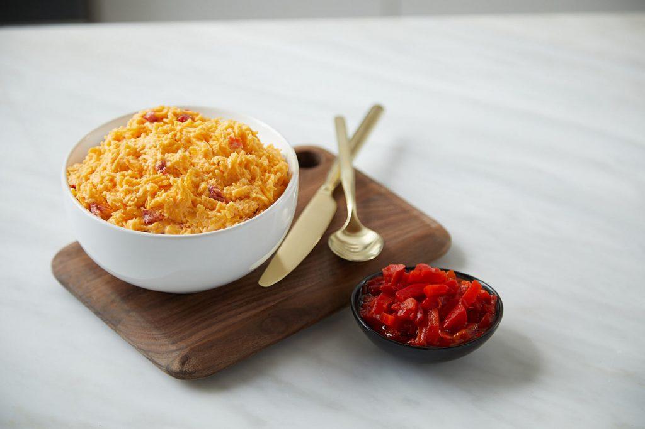

Gourmet Classic
A delicious combination of cheddar cheese, sweet, tangy pimentos and a secret combination of spices.
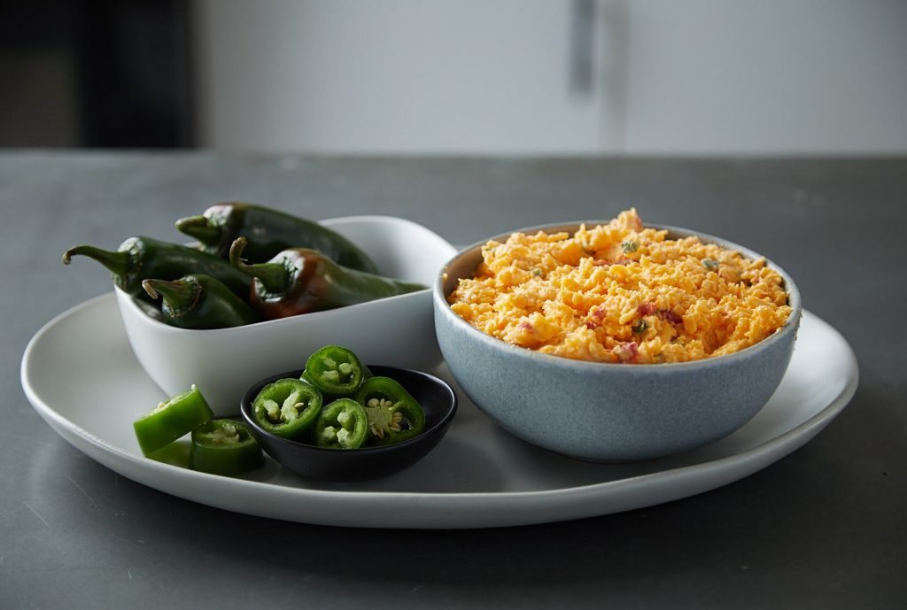

Gourmet Jalapeno
Mild
Crunchy and flavorful. Suga’s Gourmet Classic with the very light heat of unseeded jalapeno peppers.
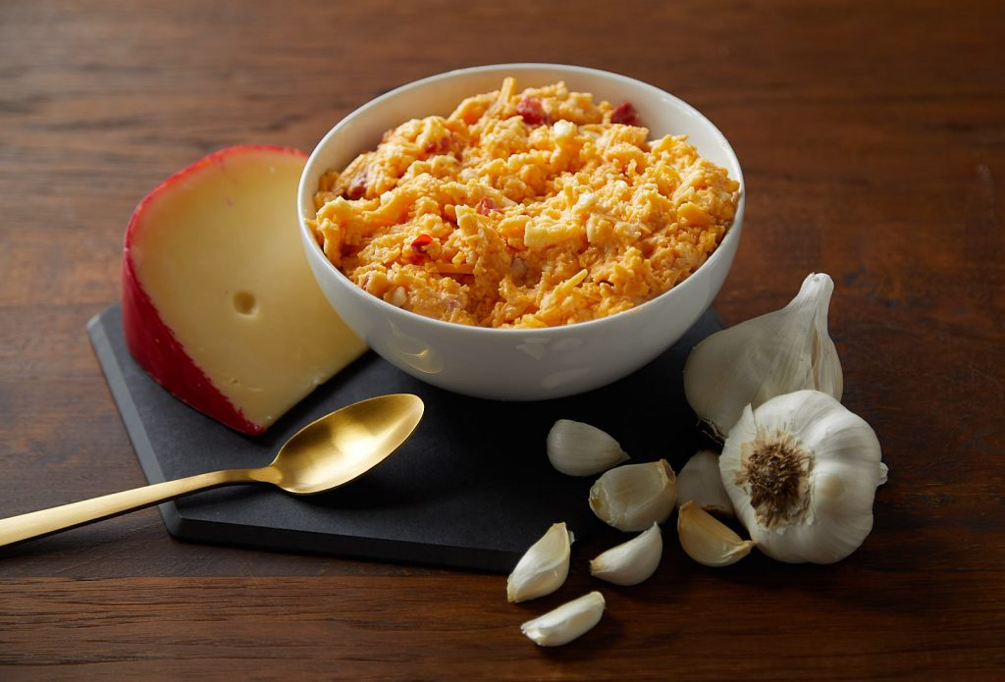

Smoked Gouda
Medium

Finalist in the 2019 Flavor of Georgia competition.
Suga’s popular, mildly tangy Gourmet Classic with smoked gouda cheese and fresh garlic.
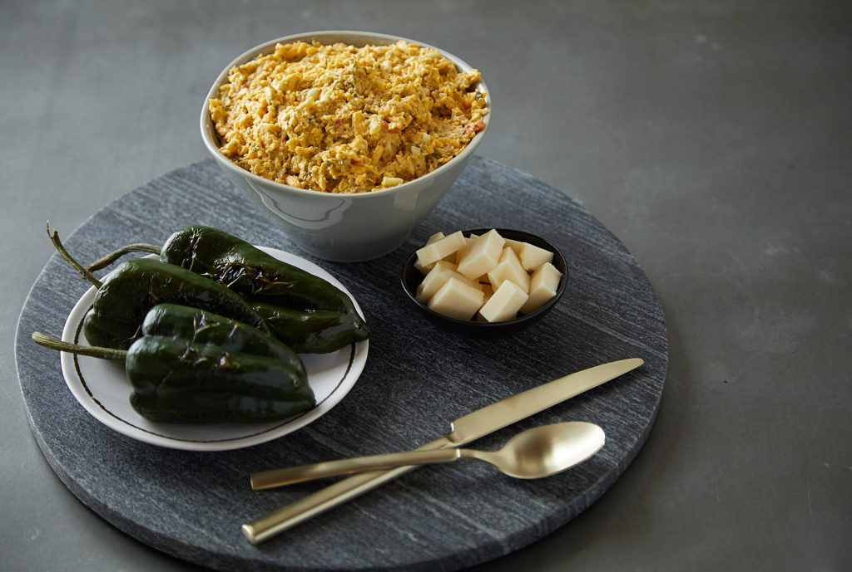

Roasted Poblano
& Monterey
Medium
Light, smoky and creamy. This twist on Suga’s Gourmet Classic offers a light-medium heat from poblano peppers and monterey cheese.
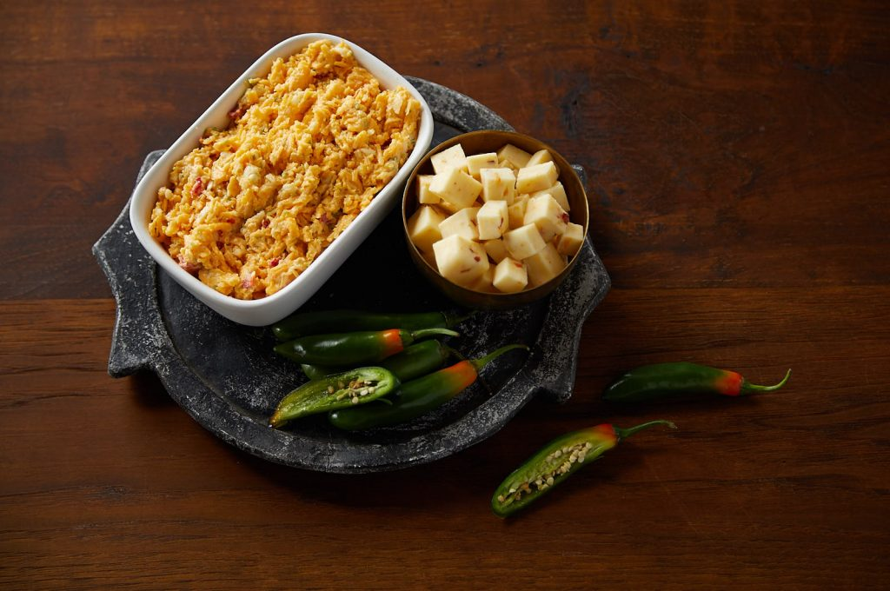

Serrano & Pepper Jack
Hot
Buttery smooth cheese with a south of the border heat. Enjoy Suga’s Gourmet Classic with serrano peppers and pepper jack cheese.
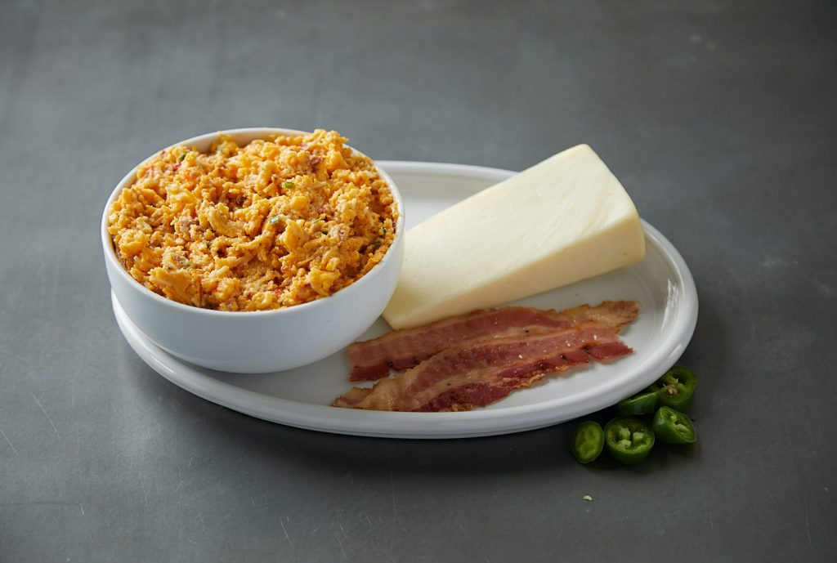

Bacon Asiago Jalapeno
Mild
Suga’s Gourmet Classic with real applewood smoked bacon, the light heat of unseeded jalapenos and asiago cheese.
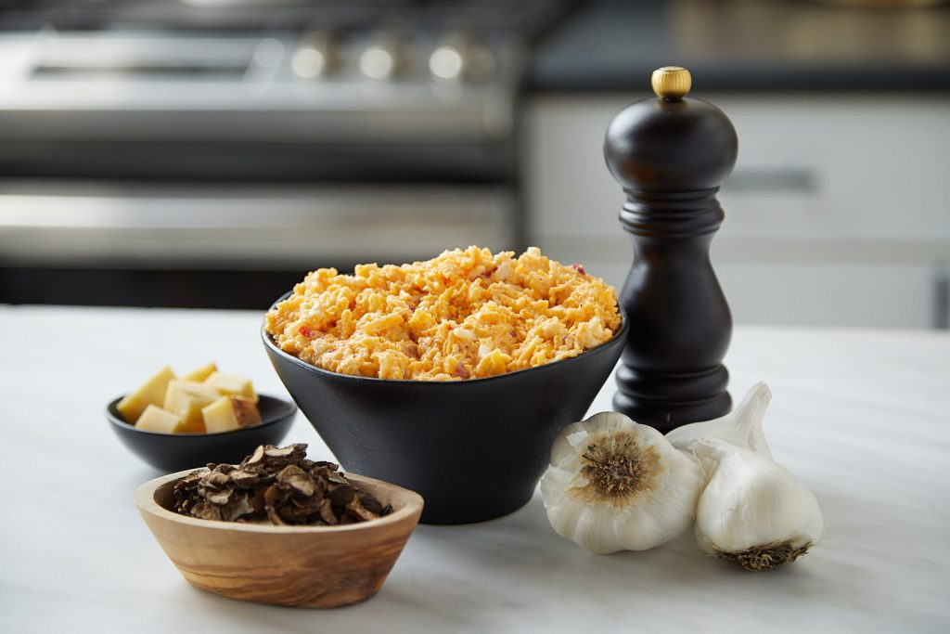

Black Truffle
Mild
Suga’s sophisticated, earthy, Gourmet Classic with a delicious flavoring of roasted garlic.
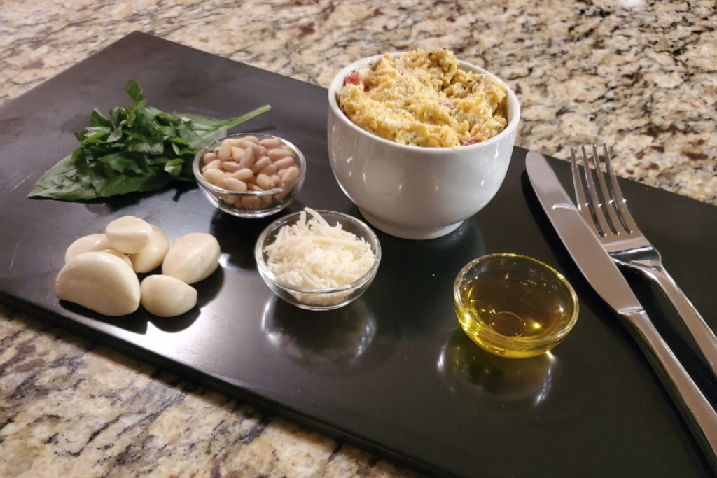

Gourmet Pesto & Feta
Enjoy rich and creamy pimento cheese with a fresh, vibrant and tangy twist.

